JOUR 4251 Packaging design
Packaging: the silent salesperson
● Not used deliberately, but ‘makes sense’ to consumers when it is used correctly
● Are not consciously perceived as persuasive cues ○ Heuristics!
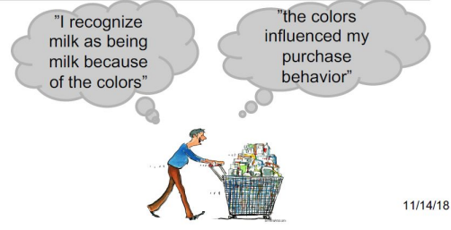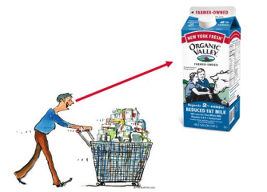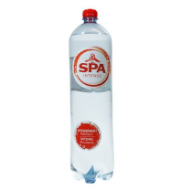
Cognition
Traditional view:
Language and cognition is facilitated by abstract representations of concepts in the brain.
Embodied cognition:
Thinking occurs in the whole body. The senses are an extension of the brain.
● Power and height
● Warmth and personality
Types of embodiment in design
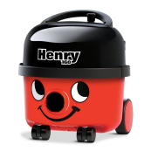
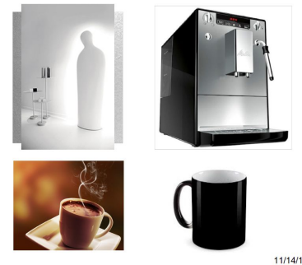
Anthropomorphism &
familiarity

Meaningful sensory
experiences
Image schemas & symbolism
Embodiment in
movement and action
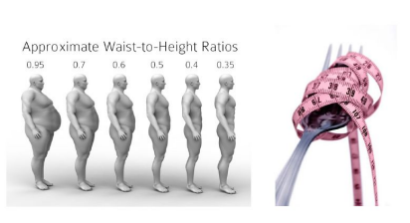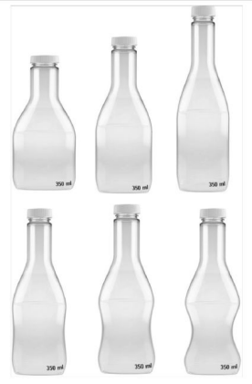
The influence of shape
Association between shape and healthiness
Results of study by van Ooijen and colleagues:
● Design (shape) serves as healthiness cue
● Design can make healthy foods more appealing
● It can serve as a cue that facilitates identification on the shelf
● The effect of design is goal-dependent
○ Health-relevant versus hedonic goal
What’s next?
Due this Thursday (April 23rd):
● Assignment #4
● Reading response #11
Next week (April 27 - May 1st):
● Exam 2
○ Monday 9 am - Friday 5 pm
○ 75 minutes to complete the exam Student Rating of Teaching by May 3

